EXP NO 16 : ONLINE INTERNSHIP REGISTRATION SYSTEM

USE CASE

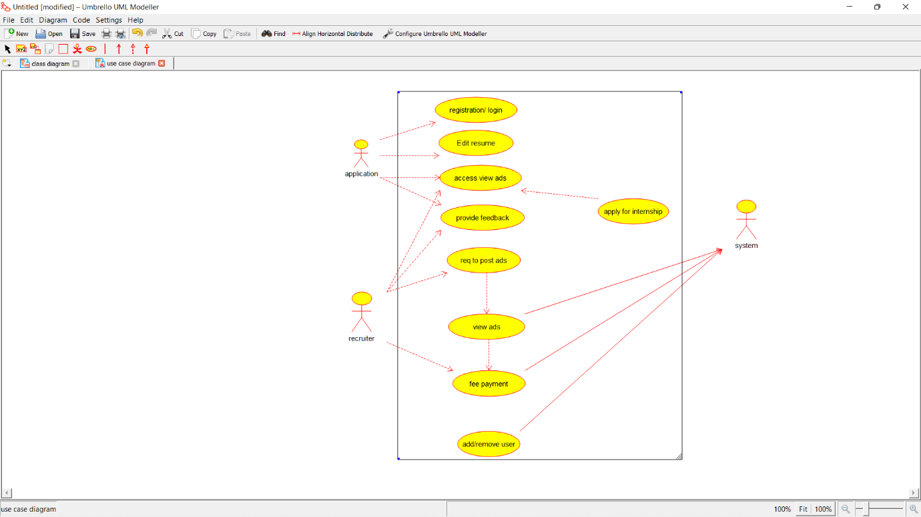

CLASS DIAGRAM

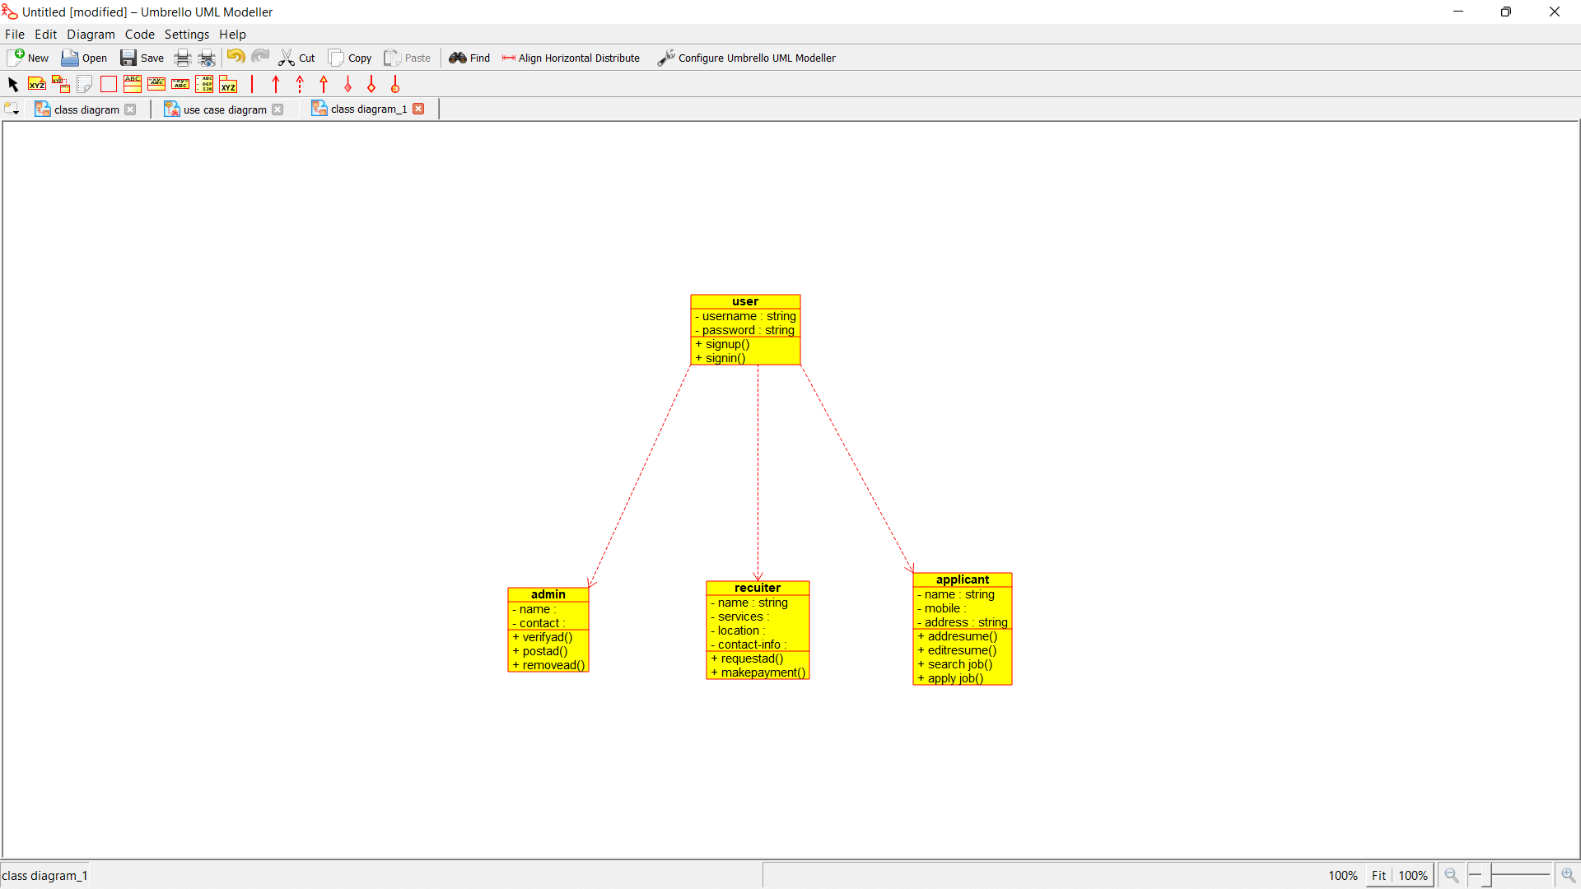

SEQUENCE

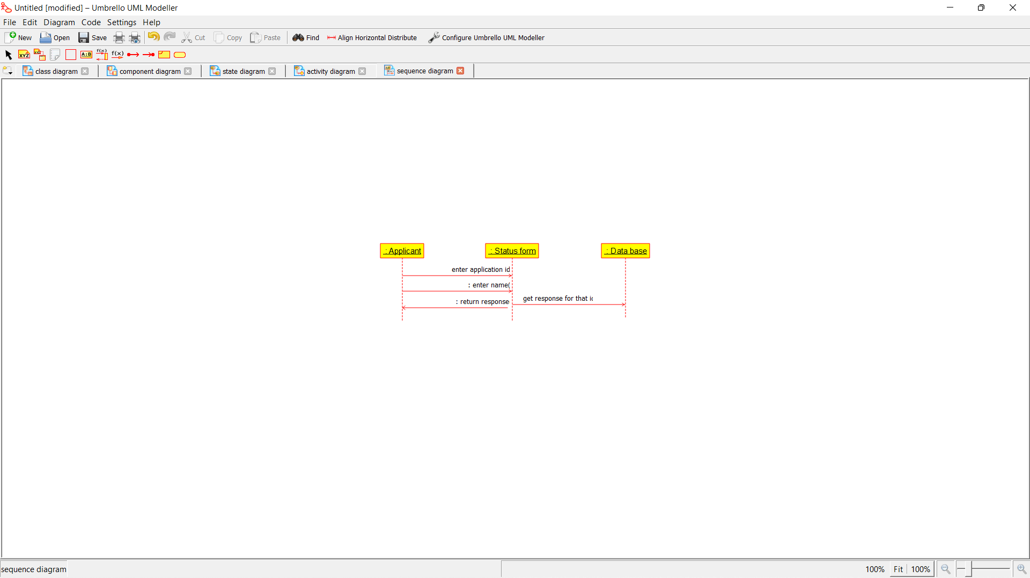

DEPLOYMENT

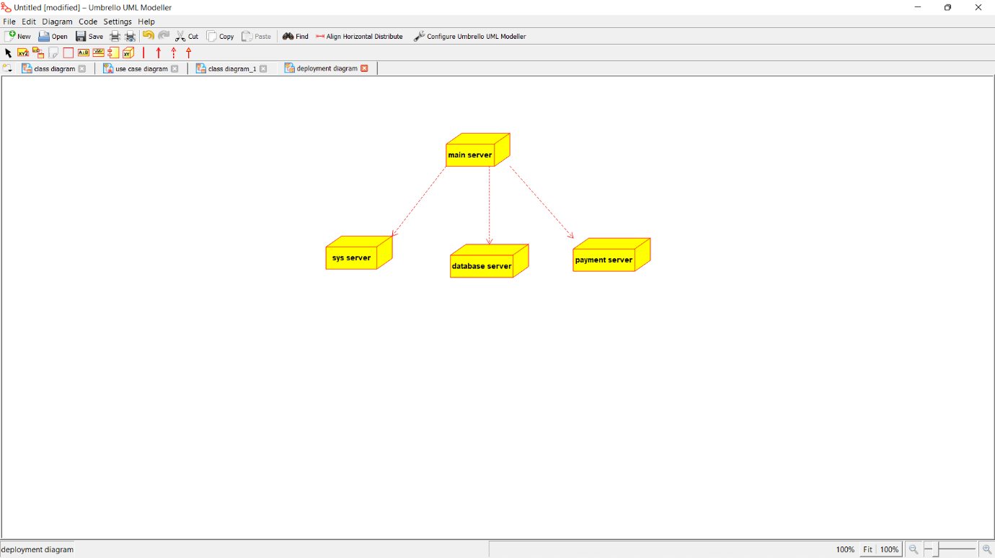COMPONENT



COLLABORATION



ACTIVITY

